|  |
| --- |
|  |
| Advanced Internet Programming |
| Weekly Portfolio |

|  |
| --- |
| Fulun He  8-12-2017 |

Table of Contents

Week 2 (31/7) Reflect on your workflow 1

Week 3 (8/8) Take an online course 4

Week 4 Read the code 7

Week 5 Presentation 9

Week 6 Setup personal homepage 10

Week 7 Meet a professional developer 11

# Week 2 (31/7) Reflect on your workflow

This week I’m going to understand and get started with the new framework “Laravel” and looking for the right way to learn it.

Since the subject aims at choosing one stack that we never used before, I found that it’s very difficult to get started by reading introductions of the stack only. The framework I’ve decided is a PHP based, both front-end and back-end with Apache web server and MySQL database framework named “Laravel”. The grammar of this framework is completely different from original PHP. Although I have a little bit of experiences of PHP (shown as Figure 1), but I’m still getting confused about this.

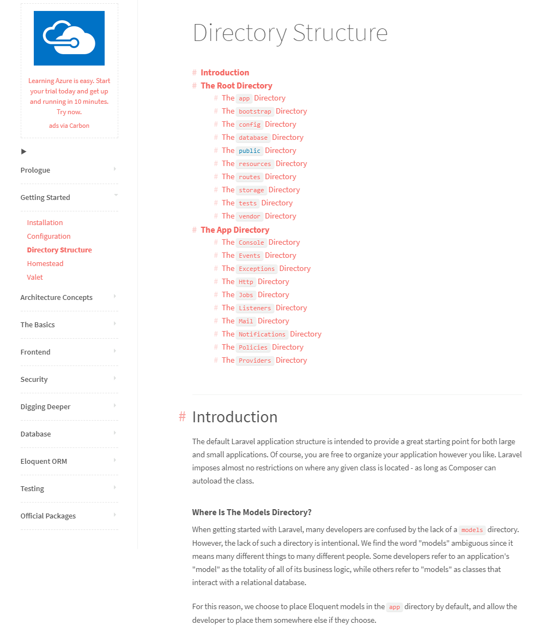

Figure

The original document of Laravel has knowledge about how it works, but by using these documents to get started is too difficult since the words cannot express everything. I After the first attempt of using Laravel and some basic understandings of it, I found that only a formal education and learning suit can help me with doing it. In this case, a “hello world” project and a welcome page of my project must be developed. Hence, after some research I found both English and Chinese learning tutorial for better understandings. (Shown as figure 2)

By using these formal tutorial step by step, the progress of my project is pushing forward quickly. Until now, I’ve finished the very first part of the project – Welcome page. (draft)

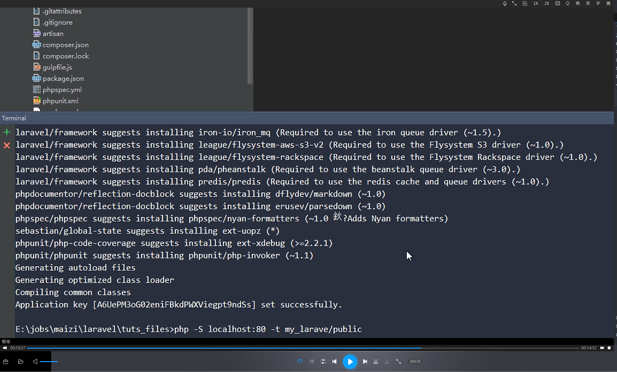

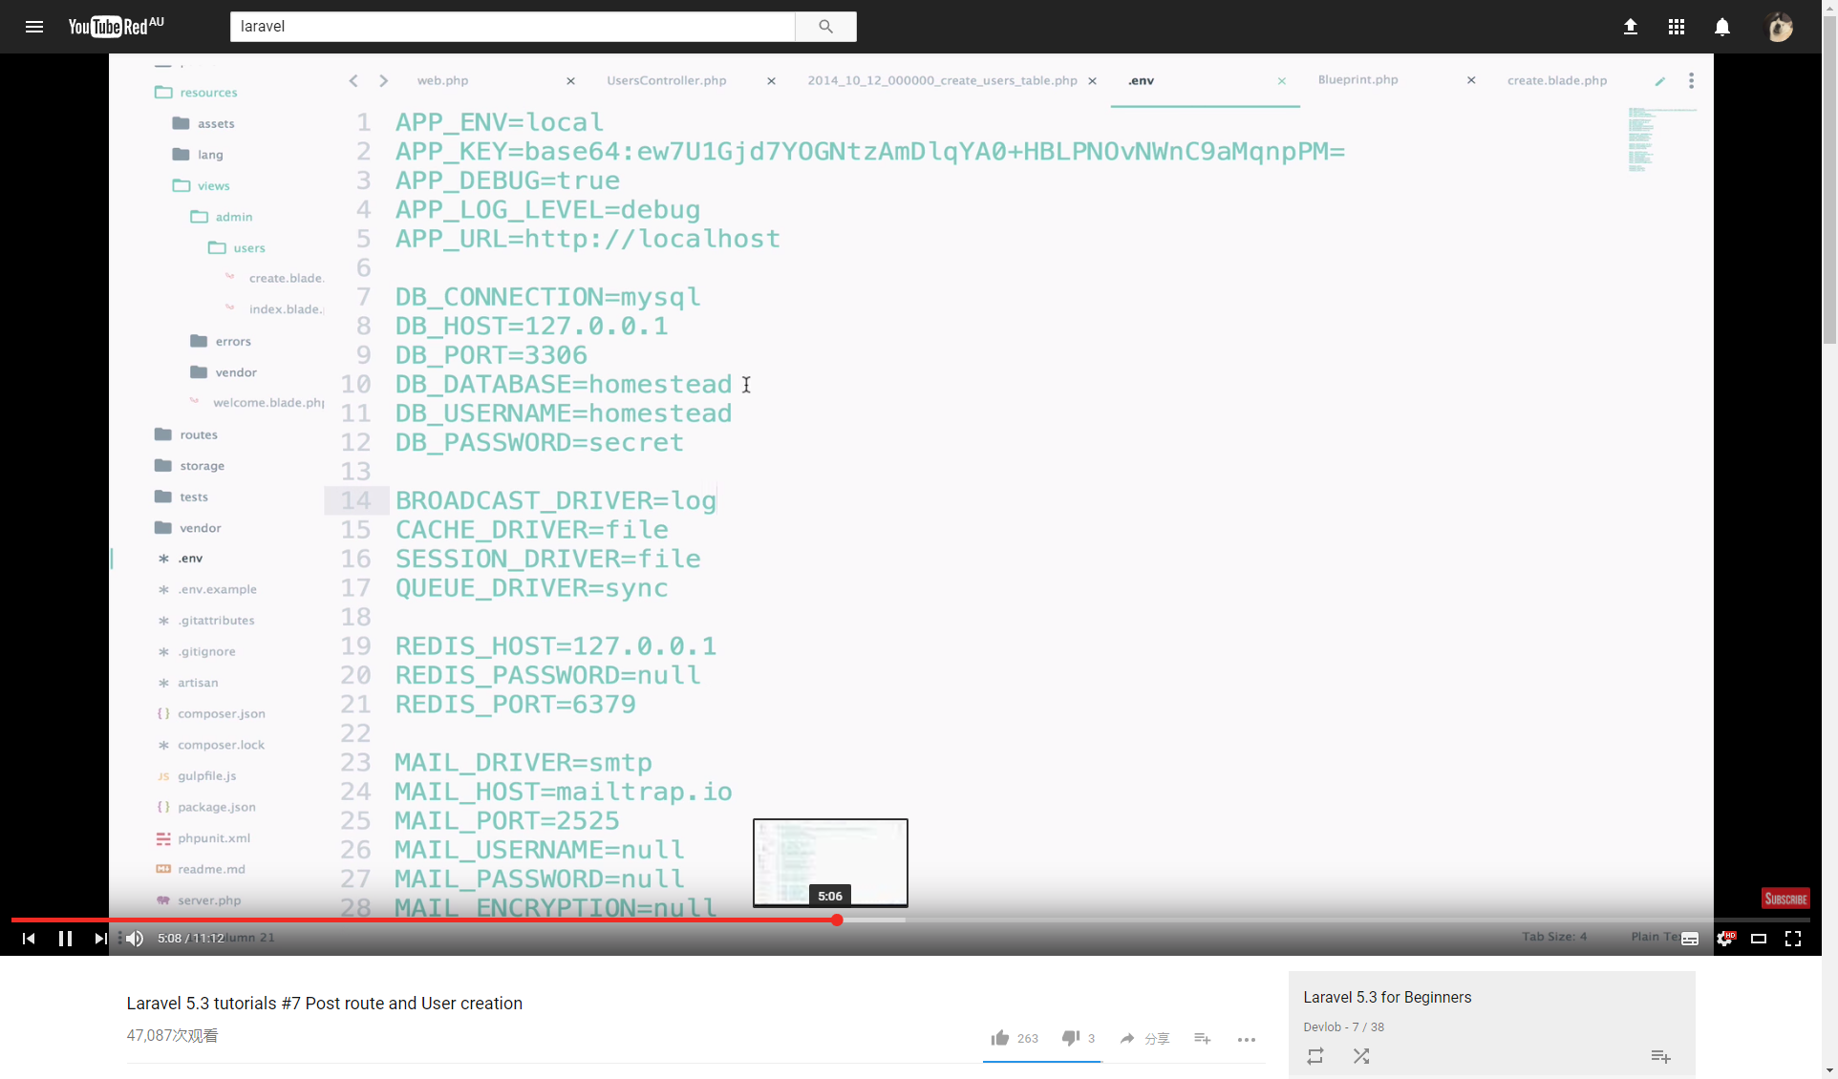

Figure

As an internet programmer, programming is the priority but not the only thing. After trying to program Laravel by myself, I found that there’s a reason why Laravel is so popular in the world. Laravel has flexibility that other frameworks don’t but appropriate stringency that controls a project not going to fragmentization. So, by using formal tutorial videos and follow these steps to do the project with Laravel will be my best choice.

# Week 3 (8/8) Take an online course

There were two courses I took this week, one for installing and optimizing the programming environment, another one for getting started with basics for Laravel.

I found some problems when copying the project over to another computer, it keeps giving error messages when I try to run it on the new computer. The original copy of the project is located at the VMware Ubuntu on my home desktop. So, it’s not even possible to run it on my laptop while I’m not at home in this case. I believe there must be some environment issue or I need to do something about the copy in the new environment.

The link of the first course – Laravel 5.3 tutorial: <https://www.youtube.com/watch?v=a8ZpAf_tNh0&list=PL3ZhWMazGi9IYymniZgqwnYuPFDvaEHJb> (From #1 - #5)

The link of the second course – Laravel 4 Essential Training:

<https://www.lynda.com/Laravel-tutorials/Laravel-4-Essential-Training/181242-2.html>

**The first course screenshots:**

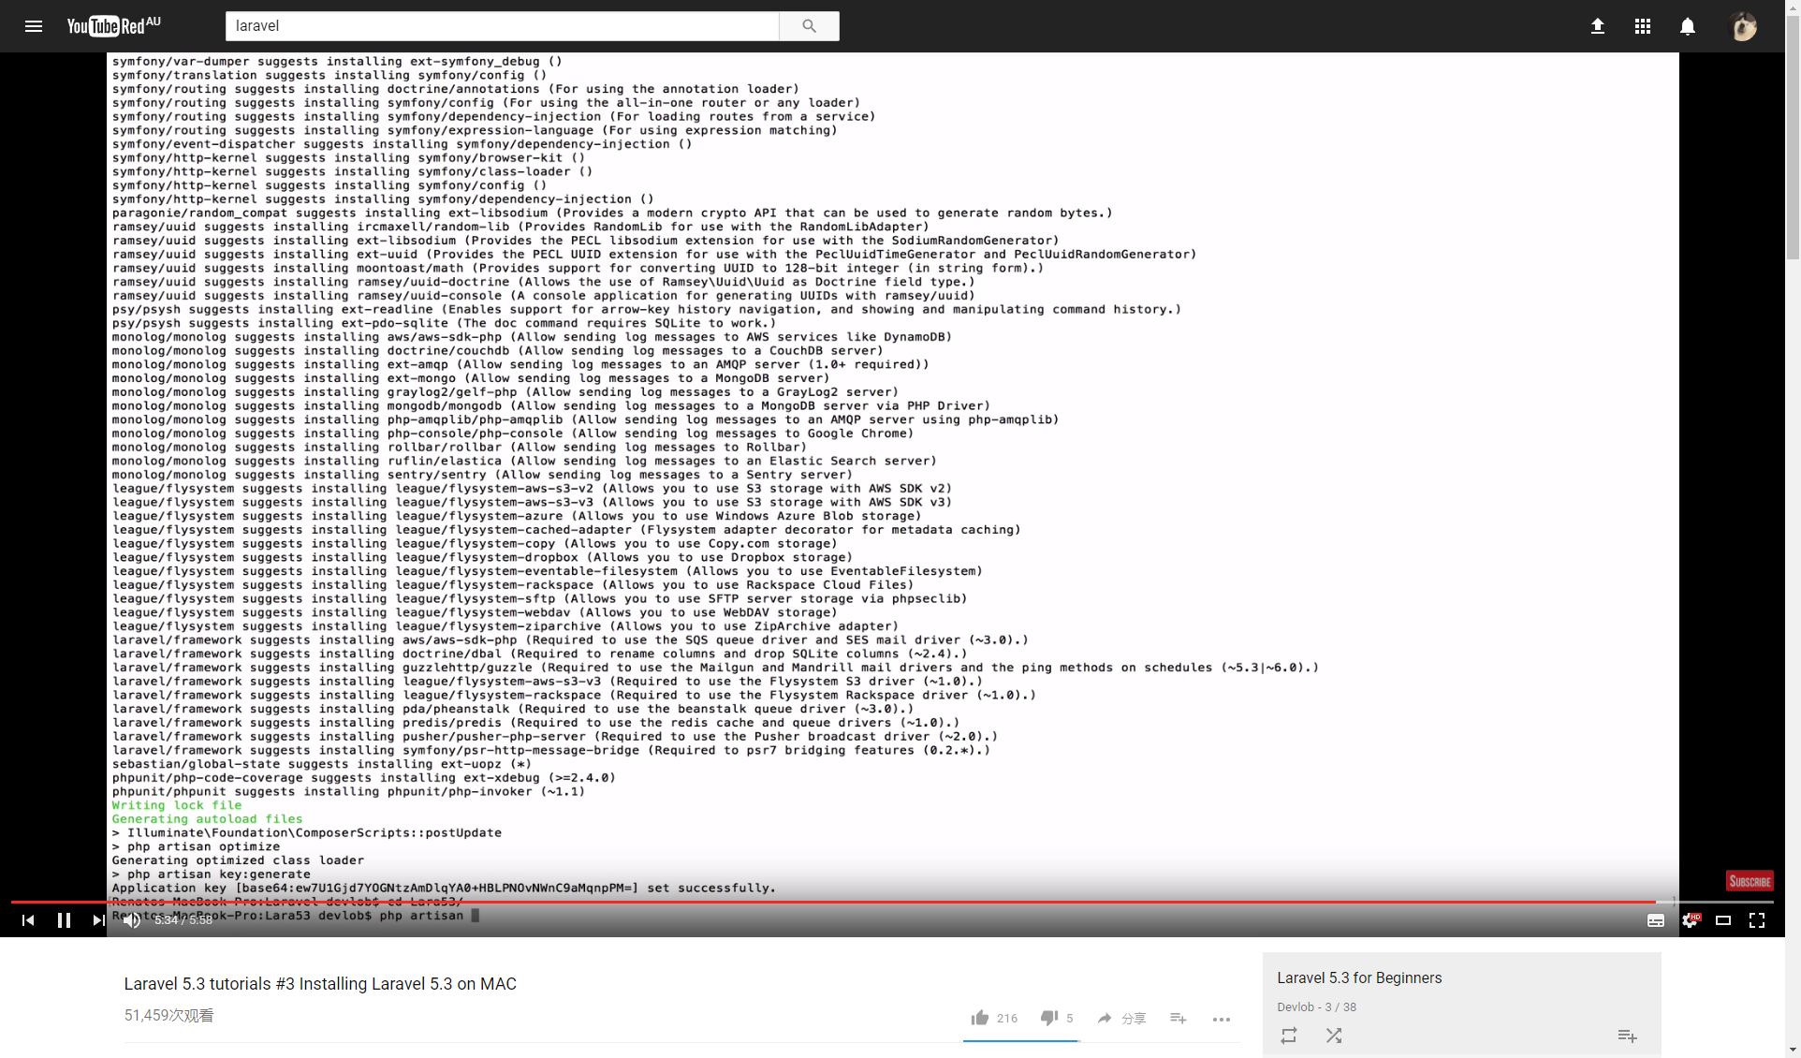

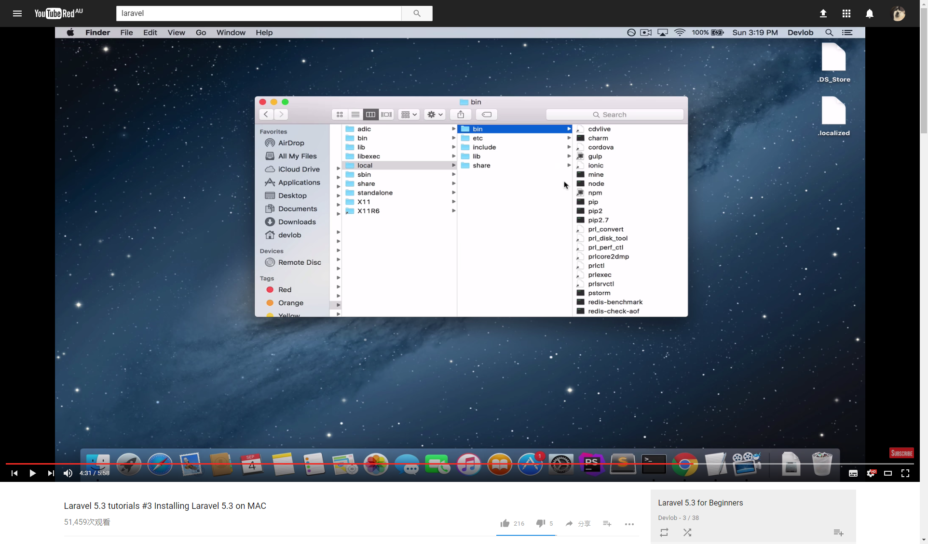

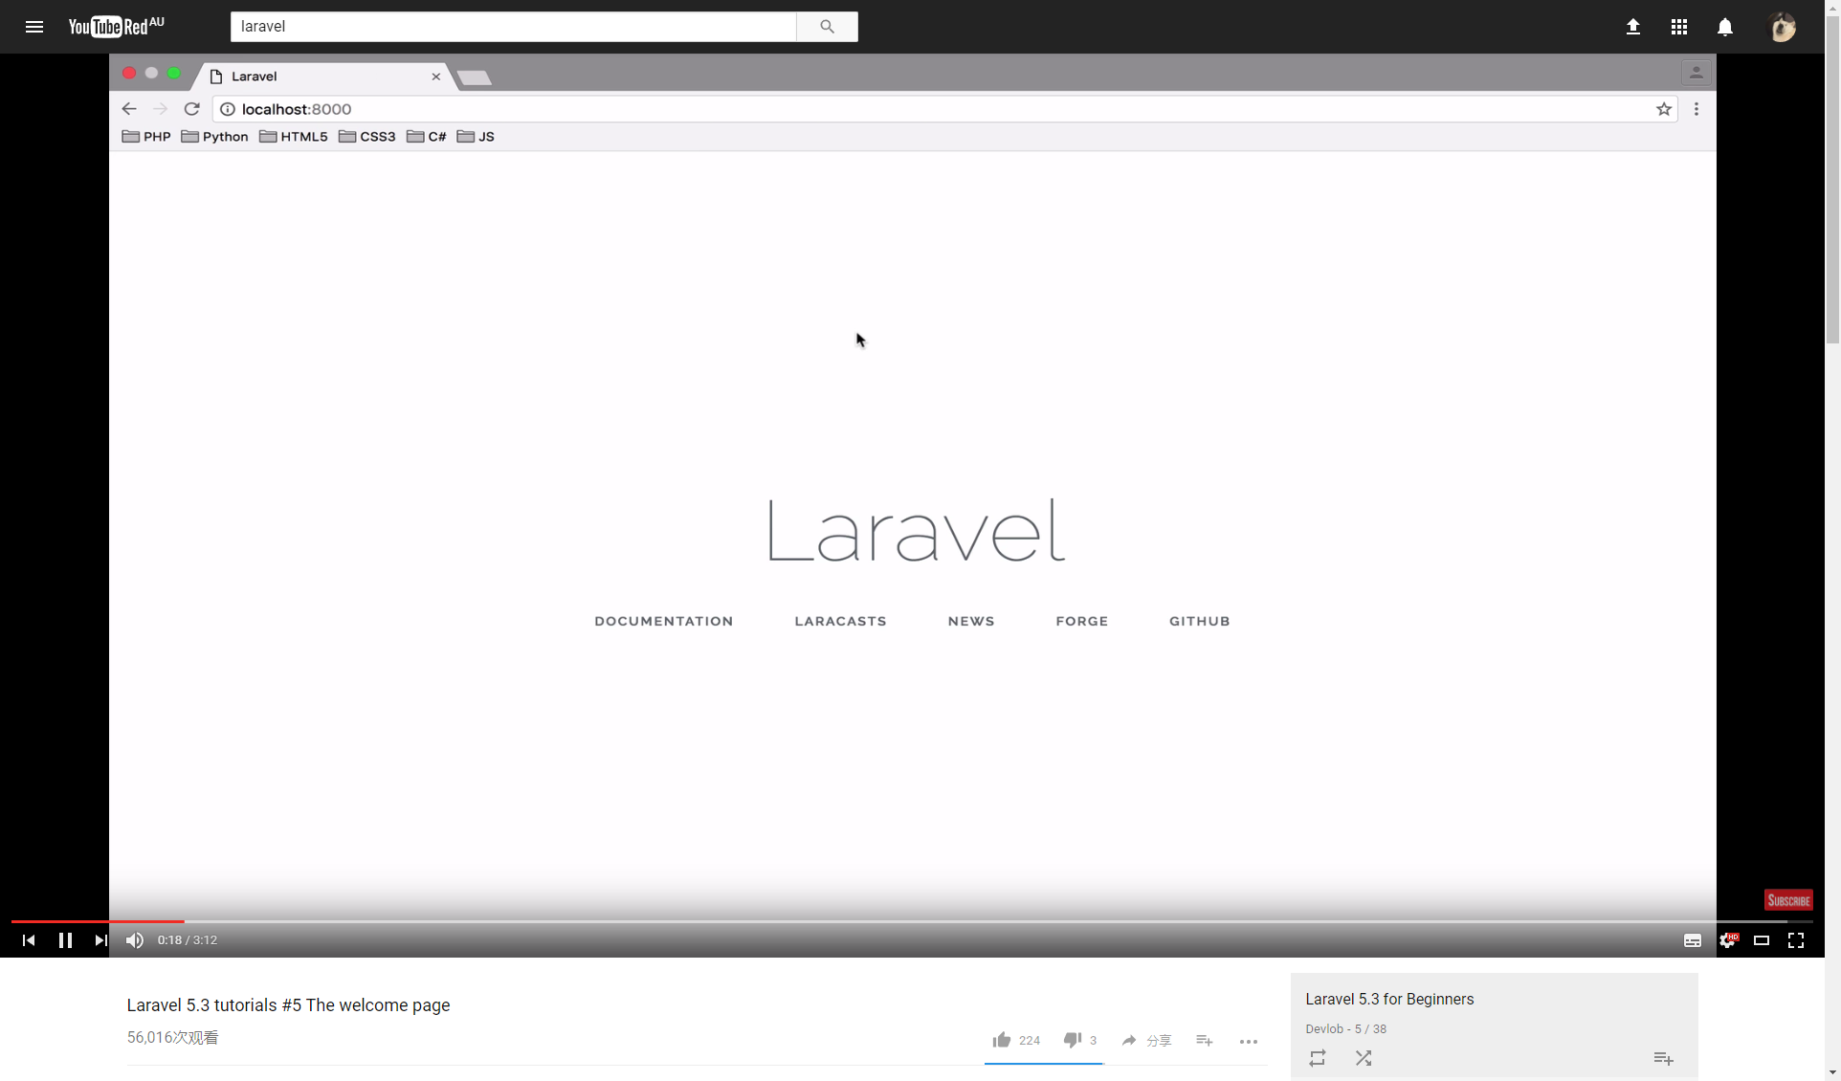

**Screenshots of the second course:**

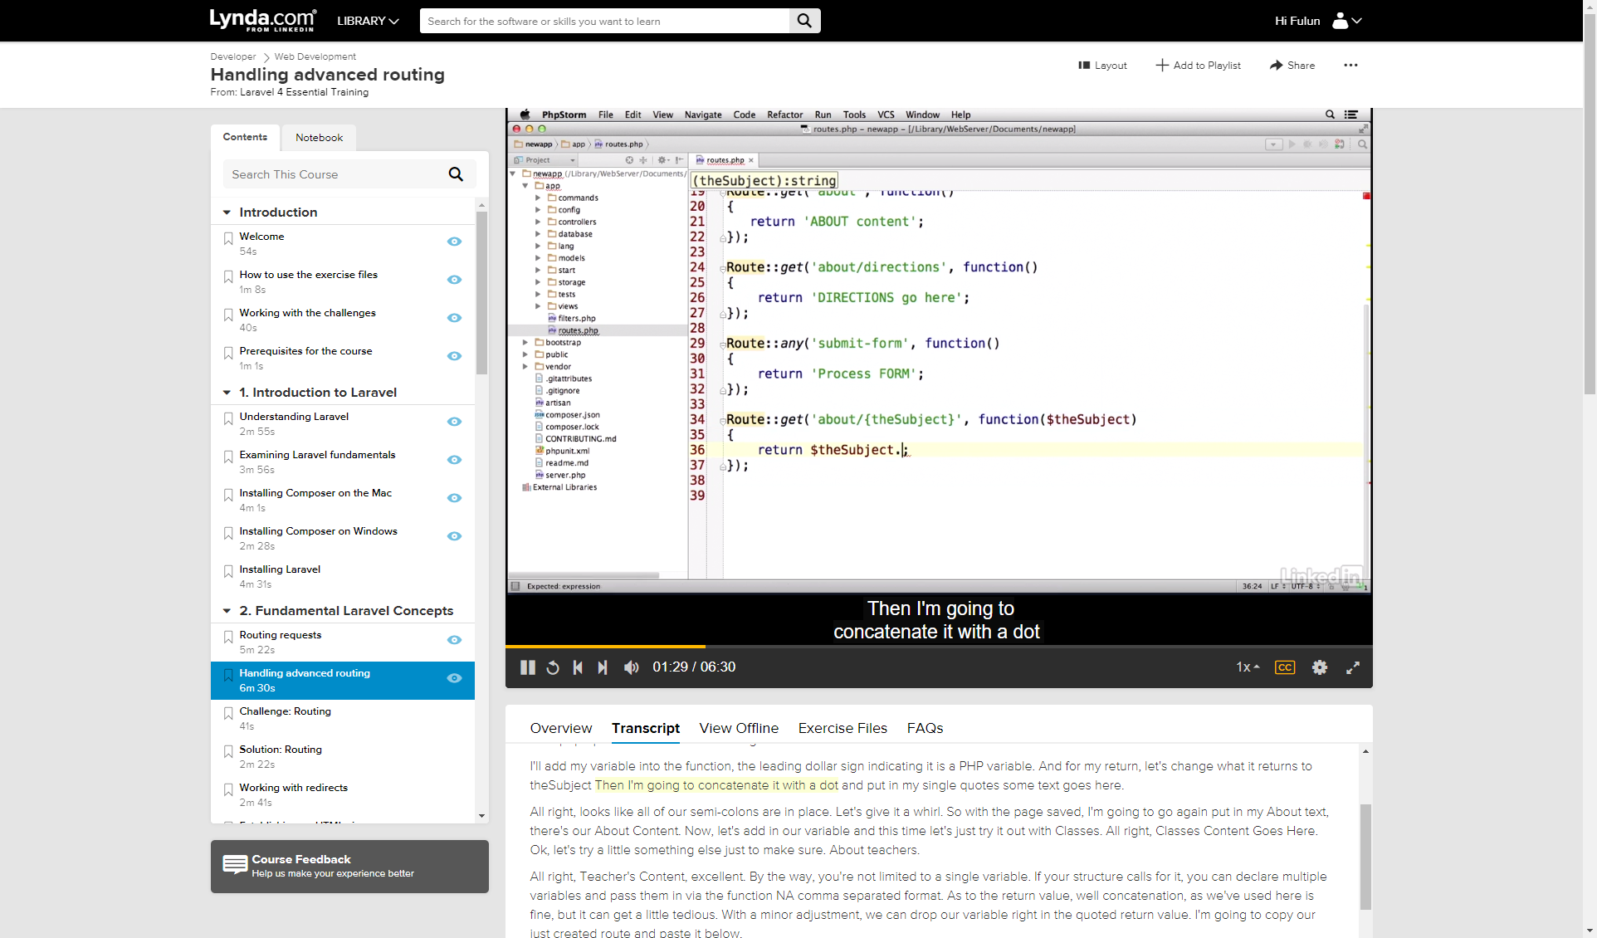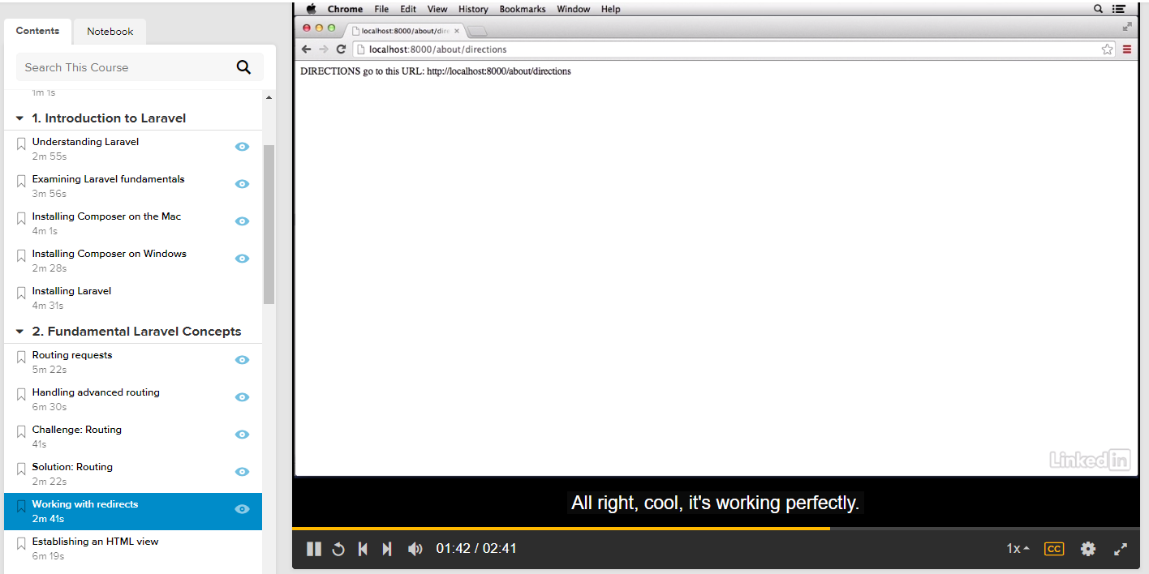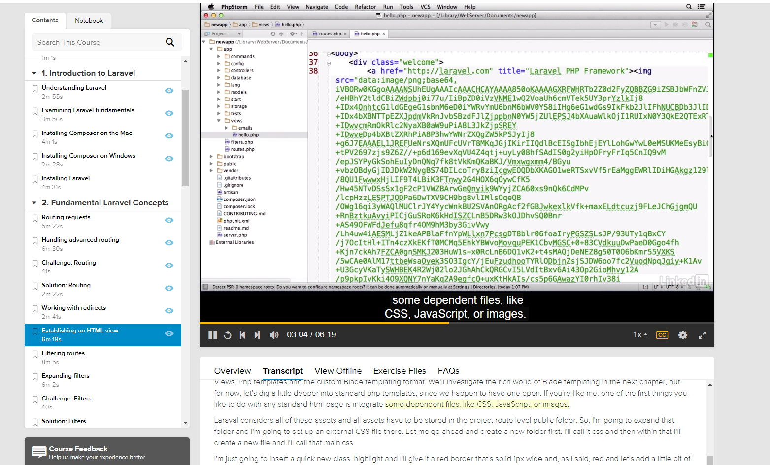

By taking these courses, I can successfully install Laravel on both Mac and Linux without any issue. As well as transferring source codes between multiple environment.

The second course has a complete Laravel learning structure. I’ve learnt some basics so I’ll start from routing part of this course.

I understood how the routes work between URL and your codes, how does the page can be published and viewed after coding, how to create new pages and connect them with route, how to use Laravel blade php template, what’s the different of session between origin PHP and Laravel.

After watching these online tutorial I found that it’s much easier to do the preparation of week4. The most interesting thing I found can be the way to use php and blade phase in a blade php file. The way to write php code in a blade php file can be : {{xxxxx}} instead of using “echo”.

# Week 4 Read the code

Route::*group*([**'prefix'** => **'admin'**,**'namespace'**=>**'Admin'**,**'middleware'**=>[**'web'**,**'admin.login'**]], **function** () {  
*// Route::get('login','IndexController@login');* Route::*get*(**'index'**,**'IndexController@index'**);  
 Route::*resource*(**'article'**, **'ArticleController'**);  
});

Route::*group*([**'middleware'** => [**'web'**]], **function** () {  
 Route::*get*(**'admin/login'**,**'Admin\IndexController@login'**);  
  
 Route::*get*(**'/'**,**function**(){  
 session([**'key'**=>456]);  
 **return** view(**'welcome'**);  
 });  
  
 Route::*get*(**'/test'**,**function**(){  
 **echo** session(**'key'**);  
 **return 'test'**;  
 });  
});

Advanced routing is much more difficult than I imagined. The document which Laravel provided online is not good enough for a beginner to start. Advanced routing is designed for multiple levels of URL directions, including redirections. The formal documentation doesn’t explain how it worked.

Route::*get*(**'admin/login'**,**'Admin\IndexController@login'**)

Means when accessing to admin/login URL, the controller named login which is in the controller page: IndexController will be launched. The controller <login> will start to control the page: <login.blade.php>.

Route::*get*(**'/'**,**function**(){  
 session([**'key'**=>456]);  
 **return** view(**'welcome'**);  
 });

This route gives session a value “456” to <key>. When accessing to homepage (which will be 127.0.0.1:8000 by default locally), the session named <key> will be set up. And return a page named “welcome” (Which will be homepage).

Route::*get*(**'/test'**,**function**(){  
 **echo** session(**'key'**);  
 **return 'test'**;  
 });

This route means when accessing to test page, a function will be launched, the session named <key> will be displayed. (echo).

The tricky part here is the logic. When accessing a specific page and a session can be set up. This session can be set as many values such as time, user name etc.

# Week 5 Presentation

Presentation about Vue.js.

Screen shots: 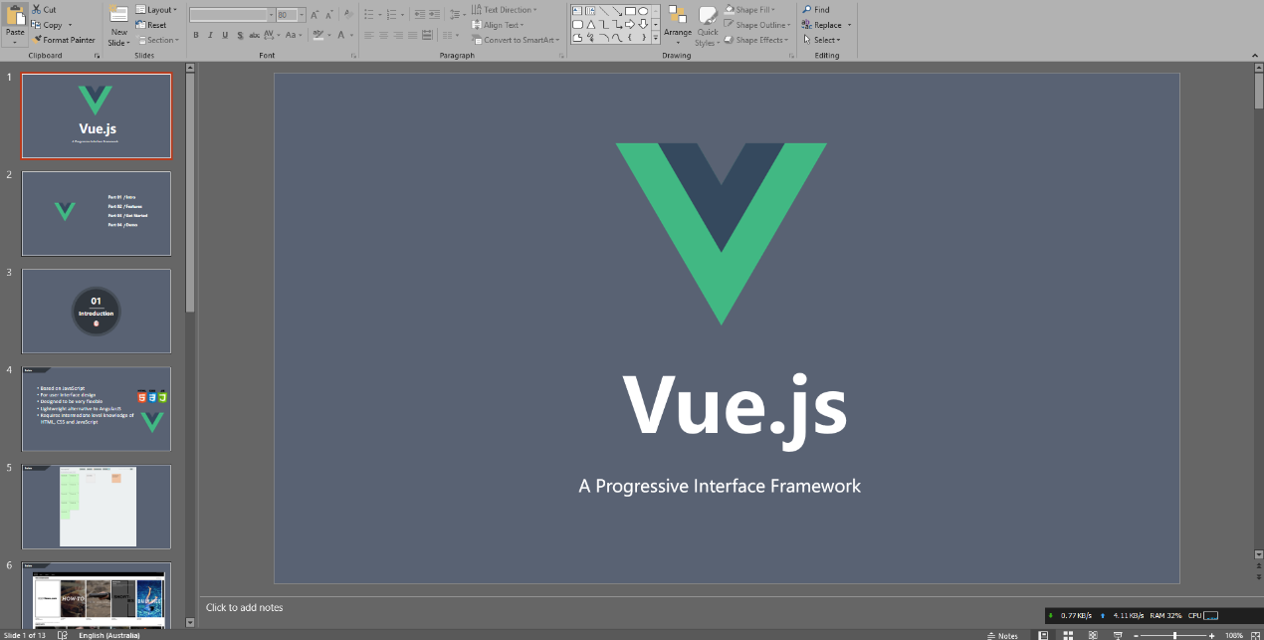

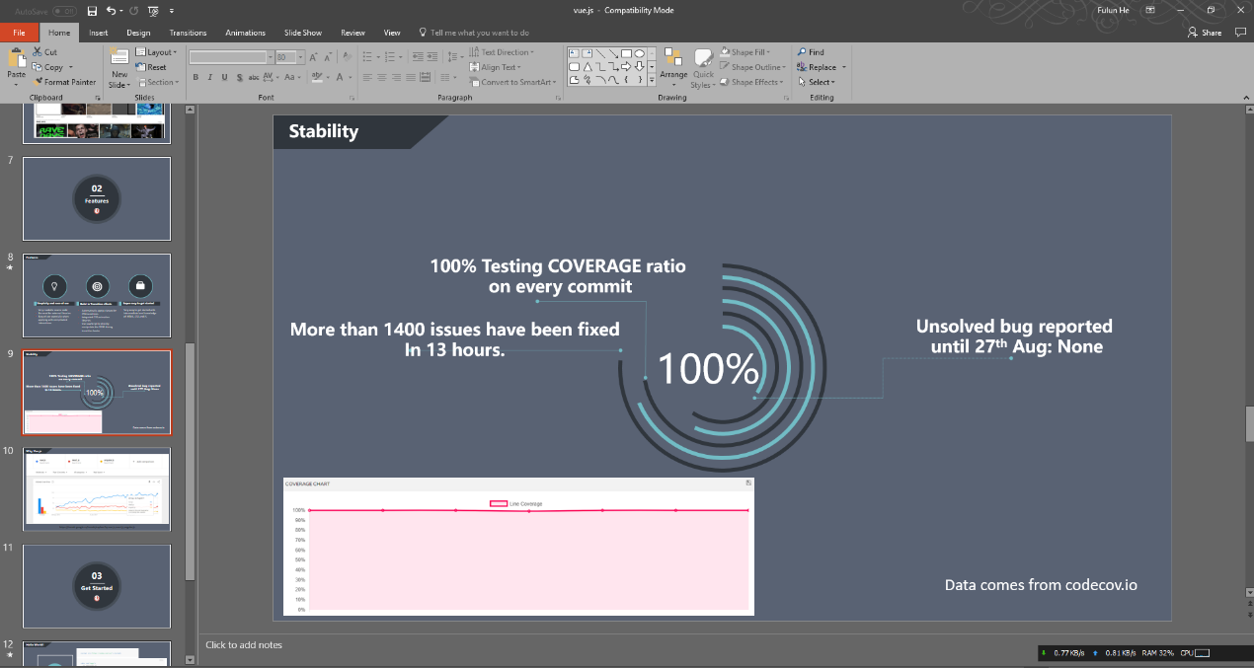

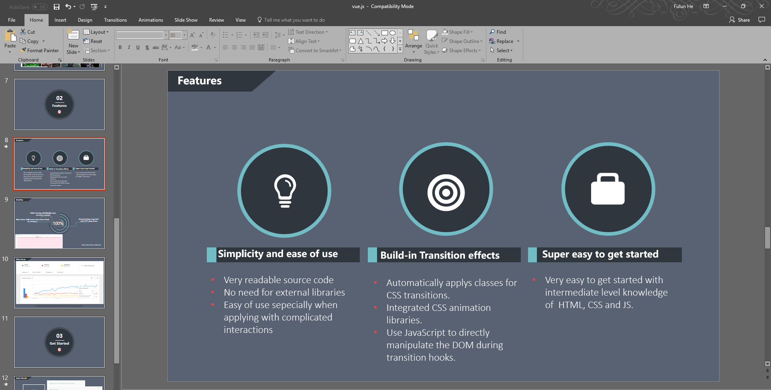

The presentation starts from introduction about Vue.js, followed by features, get started and a small demo.

# Week 6 Setup personal homepage

URL:

<http://firsthomepage.azurewebsites.net/>

It is a static HTTP, bootstrap homepage “about me”.

# Week 7 Meet a professional developer

This guy I met last Sunday is working at a local IT company called ITCiTi. His name is Yishuai Min, and he has been working for the company since last year. Yishuai Min as the Sydney local web services developer, he has created more than 10 successful products to his customers with 100% satisfaction. I knew him when I was studying in University of Wollongong and we’ve been kept in touch until now. I met him last Sunday at Coffee shop in Rhodes and talked about career, development stack, feature and other related things for 2 hours.

Regarding to my career, which is the most important part of this conversation, I found my goal for my career was not accurate or clear enough. I used to want to be a web developer and a full stack web developer if I can make it. But Min told me that was his dream but it become to impractical dream somehow. To be a full stack developer could be very hard, and might take years to become true. So, he recommended me to make a goal which I can see at this moment, for example, proficient in PHP frameworks and start with JS. Companies usually ask you what skillful languages or frameworks you can use masterly instead of how many.

Because I am studying Laravel framework at this moment, I asked him about this framework and he told me it’s a great framework and very popular now. But he also told me using bootstrap as front-end is not the best choice because it is not professional enough. He recommended me to use Laravel’s default front-end – Vue.js. When I asked him about how does he connect his study with career, he told me there’s not many you can do with and all you can do is to get used to one framework and do your best.



# Week 8 Reflect on and improve your time management

Previous week calendar:

|  |  |
| --- | --- |
| **Monday, [4]** | AIP class: collect feedback from tutor, rethink about frontend with group members, redesign the logic of operating in backend. |
|  |
| **Tuesday, [5]** | Did nothing about AIP or programming. |
|  |
| **Wednesday, [6]** | Updated: backend: Category system redesigned. Read lots of documents about connecting category to articles.  Didn’t finish it but category works fine.  Trying to get some help from one of my friends, didn’t work.  Trying to get correct solution from video tutorials, didn’t work. |
|  |
| **Thursday, [7]** | Still trying to get category system working. But didn’t make any progress.  Fixed some bugs on frontend. |
|  |
| **Friday, [8]** | Still trying to get category system working. And it worked fine with backend now. Trying to get it connected with frontend.  Laravel 5.5 released, read update notes, need to communicate with group members about updating or not. |
|  |
| **Saturday, [9]** | Did nothing about AIP or programming. |
|  |
| **Sunday, [10]** | Still trying to get category system working.  Finished weekly preparation of AIP, worked fine. |
|  |

This week’s plan:

|  |  |
| --- | --- |
| **Monday, [4]** | AIP class: need to redesign category system again, communicate with group members.  Read Laravel 5.5 updates and decide if we are going to use it.  Need to start looking at connecting frontend with backend and winding up. |
|  |
| **Tuesday, [5]** | Prepare to start redesign category system.  Look up online for some solutions.  Try to find some reference or open project from online community or GitHub. |
|  |
| **Wednesday, [6]** | Finish category system. |
|  |
| **Thursday, [7]** | Nothing to do about programming. Need to prepare exam for Friday. |
|  |
| **Friday, [8]** | Connect frontend and backend and debugging. |
|  |
| **Saturday, [9]** | Finish at least one fully operational function for background. |
|  |
| **Sunday, [10]** | Day off. |
|  |

**What really happened this week:**

|  |  |
| --- | --- |
| **Monday, [4]** | AIP class: Decided to use original way to design category system.  Read Laravel 5.5 updates and decided we are NOT going to use it. |
|  |
| **Tuesday, [5]** | Look up online for some solutions.  Category worked fine. |
|  |
| **Wednesday, [6]** | Category system connected with frontend by getting help from friends and watching videos. |
|  |
| **Thursday, [7]** | Nothing to do about programming. Need to prepare exam for Friday. |
|  |
| **Friday, [8]** | Didn’t do anything about it. Still immersed in the success of category system. |
|  |
| **Saturday, [9]** | Finished preparation of AIP, and fixed some bugs of frontend. |
|  |
| **Sunday, [10]** | Watch video tutorials about Laravel reset password and email service functions. |
|  |

I found that the previous week was great and I learnt a lot of new things about Laravel. I was surprised that I did that much work in one week but still, that was not good enough compare to other professional developers. But I found that writing down what I have done can be very helpful for me. Not only for improving my developing skills, but also for my daily life in any aspects.

Hence, I made a plan for this week and hopefully I can make it.

But I found that I missed too many unpredictable factors such as other assignments go wrong or any other things come up. I found that focusing on only developing web (AIP in this case), can lead to serious consequences. And I couldn’t finish what I had planned either.

During this week, once when I was trying to follow the plan on Tuesday I found the plan of Monday didn’t go well so I couldn’t do anything on Tuesday by following the plan. This can be very serious when I plan to do something important because every work has prerequisite and everything will go wrong if one task fails. This is one important improvement I need to focus on in the future.

Also, when I was planning the calendar for this week, I couldn’t figure out any specific task that I need to put into my plan quickly. I have to search my previous work and some fragments of my project to formulate the plan. This can be improved by recording and planning persistently.

# Week 9 Ask a good question on Stack Overflow

Question link: <https://stackoverflow.com/questions/46526307/how-to-change-redirected-local-address-of-password-reset-request-in-laravel5-4>

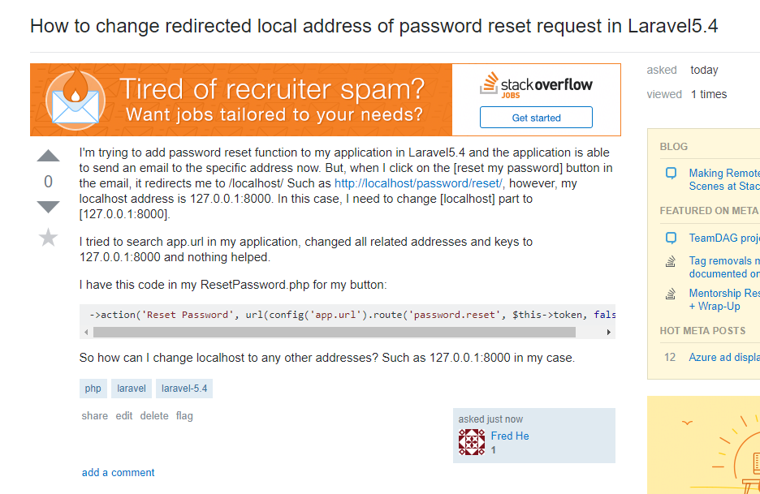

My profile:

